**Project Plan 2 – Kyle McKanna**

Idea: 2D Platformer

**List of Features:**

*- Player can move, jump, and sprint*

*- Player is scored based on how fast they finish the level*

*- Multiple levels with obstacles such as pits, enemies, and hazards*

*- Powerups to assist the player*

*- Collectibles to grab to earn the player extra points*

*- Level Select to view/replay completed levels*

*- Saving/Displaying of player’s best scores on a level*

**Features Completed at the end of Final Iteration**

* Additional Level(s)
* Level Selection Screen to use to move between levels
* Locking Levels until completing the previous level
* Powerup that allows the player to jump higher, level that uses this powerup
* Button to reset the player if they get stuck

**Build/Execution Instructions:**

**The project is hosted at the following public github repository:**

[KyleM1413/IntroGameProgrammingProject (github.com)](https://github.com/KyleM1413/IntroGameProgrammingProject)

Note: Be careful when pulling the source to have a short path leading to the directory the project is extracted to, otherwise some of the project files will likely fail to extract on windows due to maximum file path length constraints

Included in the github repository is the full Unity Project located within the Dev/Project Folder, Opening the Dev/Project Folder in Unity 2019.4.9f1 will allow you to build the project, a built version of the latest version can also be found within the Dev/Project/Builds/Windows(x86) Folder and can be run by opening Project.exe

Levels can be played using the Menu Screen, which also includes a button to exit the application. Until the previous level is cleared, levels will be locked and unable to be played

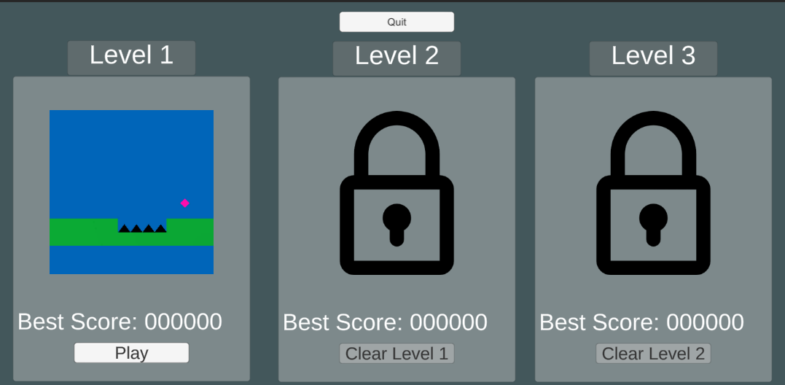

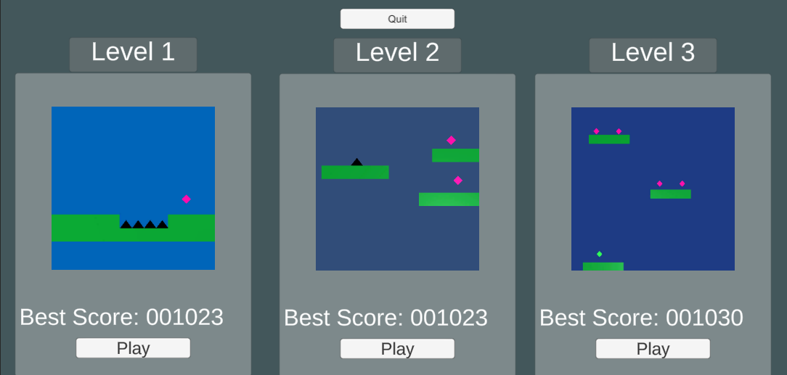

The menu also shows the best score the player has achieved on a particular level.

While in a level the player can use WASD/Arrow keys to move the character, Space to jump, and Shift to sprint which causes the character to move faster, the player can use the R key to reset to the spawn point in the event that they get stuck or otherwise need to reset. If the player falls off the level or collides with a spike they will also be reset. The player is scored based on how fast they complete the level and how many collectibles they pick up during the course of the level.

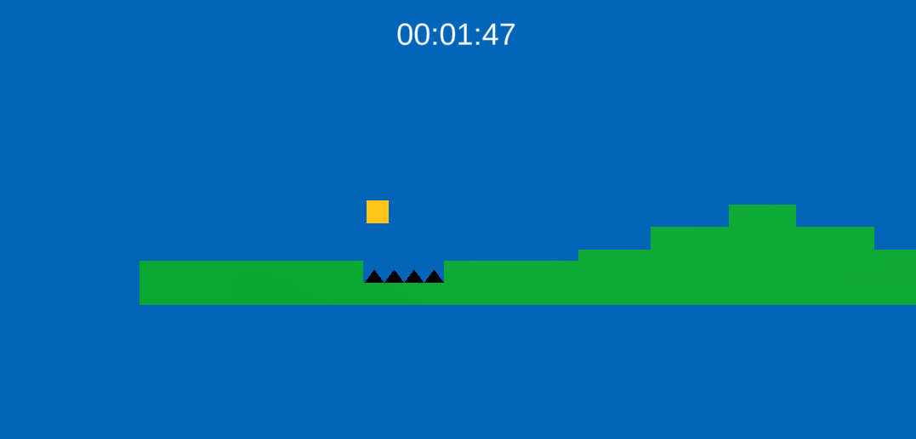

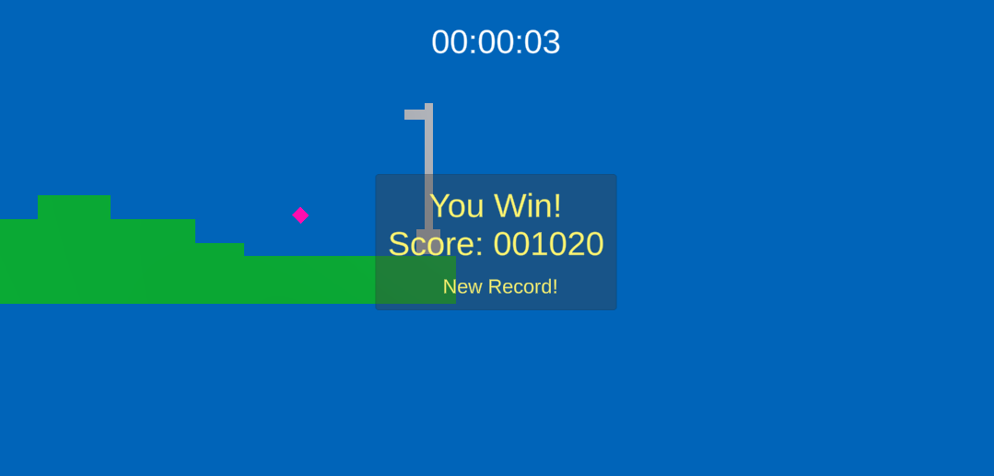

The third level also has a jump powerup collectible that increases how far the player can jump for the duration of the level, which is used to have the level be on a much more vertical scale

